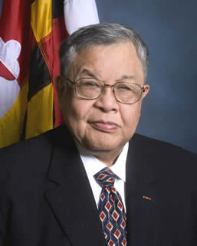

Mr. Edward Chow, Jr.
Secretary of Veterans Affairs
Edward Chow, Jr. was appointed Secretary of the Maryland Department of Veterans Affairs on September 1, 2009. He was previously Deputy Assistant Secretary for Policy with the United States Department of Veterans Affairs; City Administrator for Kent, Washington; and a Cabinet Officer for the State of Washington. He has extensive experience in the public, private and nonprofit sectors and is a Life Member of AMVETS, Disabled American Veterans, Veterans of Foreign Wars, and Vietnam Veterans of America. Secretary Chow was commissioned a 2nd Lieutenant in 1962 after completing R.O.T.C. and his undergraduate degree at Seattle University. He served in Germany and completed his service as a Captain in Vietnam (1967) where he was awarded the Bronze Star. He later received a Masters in Public Administration from the University of Puget Sound. A devoted father, Secretary Chow has a son and daughter, who are both medical doctors, three grandsons and a granddaughter.

