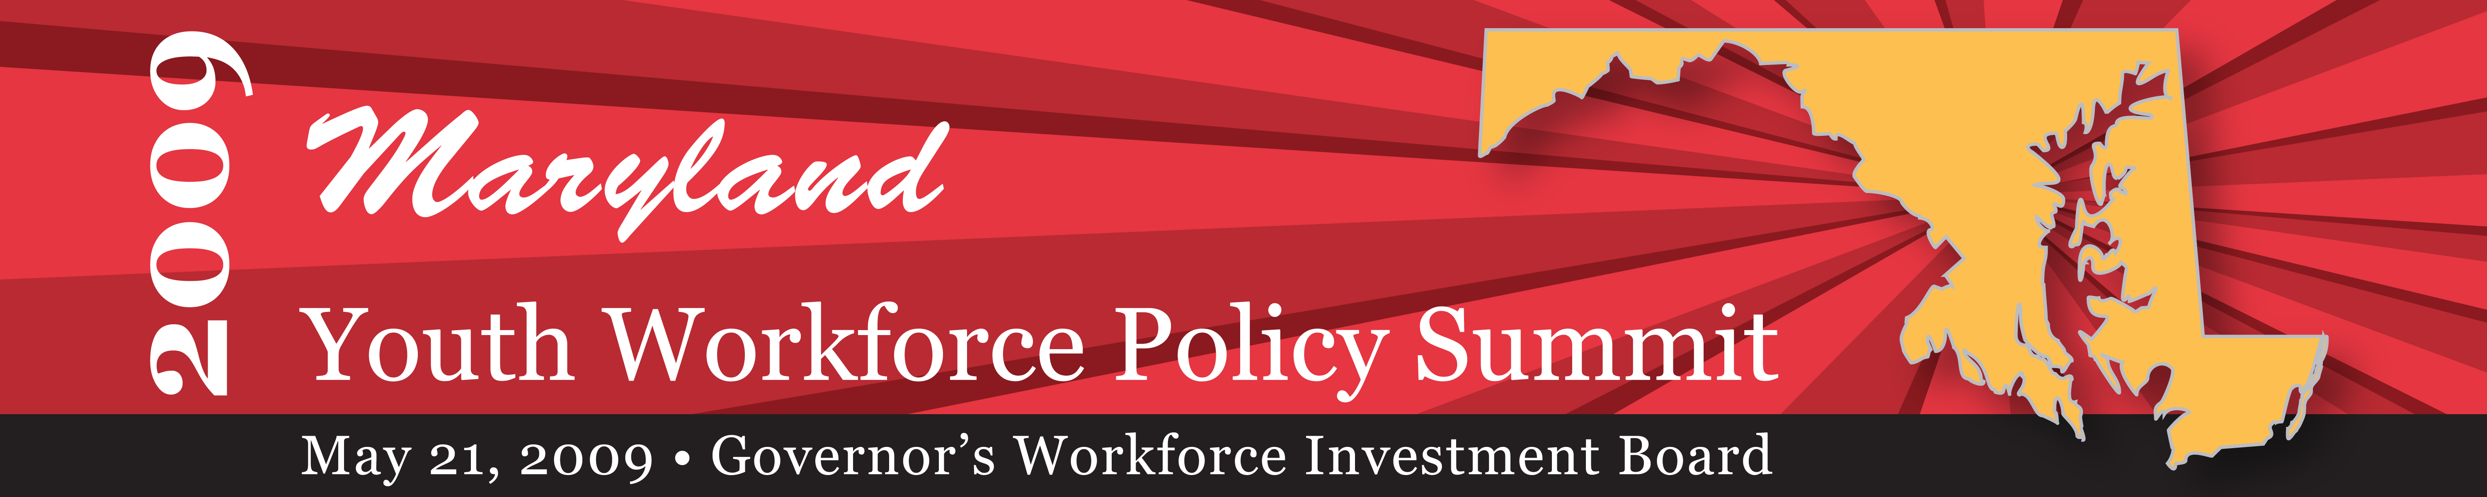

April 28, 2009

Dear Youth Workforce Policy Stakeholder:

Maryland’s workforce is one of the state’s most valuable resources, and is a top priority for the O’Malley Administration. The Governor’s Workforce Investment Board (GWIB) established the Emerging Workforce Committee to research the issues and promising practices and draft recommendations on strengthening support for our youth and the emerging workforce. The committee, comprised of members representing a broad range of public, private and non-profit agencies and organizations, has worked diligently over the past year. They are ready to release their whitepaper and draft policy recommendations designed to ensure that Maryland’s youth have the skills and supports necessary to be workforce ready.

Please join the GWIB on Thursday, May 21, 2009, as we convene the Maryland Youth Workforce Policy Summit to review the Youth Workforce Policy Whitepaper. The Summit is designed to bring together the highest levels of leadership from industry, organized labor, government and education to:
- validate the critical need for investing in the development of an educated and skilled emerging workforce as an economic competitiveness issue for the State;
- prioritize and spotlight the key issues directly related to promoting a prepared and qualified emerging workforce;
- garner support for policy recommendations and recruit champions from across the stakeholder community; and
- identify partners willing to jointly initiate a bold Campaign for Maryland’s Future Workforce.

Maryland needs to provide clear guidance for state-wide policy in order to improve the workforce readiness of its youth as they transition to the workforce. The State must ensure that it meets business’ future workforce needs in order to keep the state competitive in the global economy and grow the ranks of the middle class.

What: Maryland Governor's Workforce Investment Board Youth Workforce Policy Summit
When: Thursday, May, 21, 2009 - 8:30 a.m. -12:30 p.m. (registration begins at 8:00 a.m.)
Where: Rockland Hall Banquet Room, Stevenson University’s Owings Mills Campus
10945 Boulevard Circle, Owings Mills, MD 21117
How: Register at https://www.conference.com/eventmanager/onlineregistration.asp?eventcode=POP

We look forward to seeing you at the Summit on May 21st and welcome your active participation in this important discussion. If you have any questions, please contact Trudy Chara at 410-767-4145 or tchara@gwib.state.md.us. Together, we will unite in a common goal of ensuring the emerging workforce has the skills necessary to meet the needs of Maryland employers.

Sincerely,
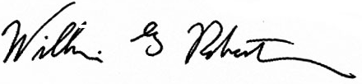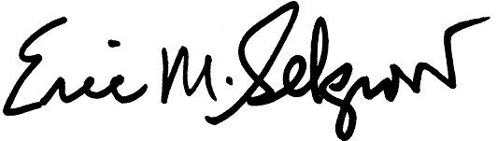
William G. “Bill’ Robertson Eric M. Seleznow
GWIB Board Chair GWIB Executive Director
TELEPHONE: 410-767-2408 • FAX: 410-383-6732
TTY USERS, CALL VIA THE MARYLAND RELAY SERVICE

1100 NORTH EUTAW STREET, ROOM 108
BALTIMORE, MARYLAND 21201

